**Our Energy Future**

**Corn Ethanol**

Ethanol is a byproduct of microbial anaerobic sugar metabolism (aka *fermentation*), toxic to the bacteria but useful to us. It is a clear, colorless *volatile* (meaning it has a measurable vapor pressure) liquid, is used in products like beer and gasoline additives, and is the most widely used biofuel in the United States.

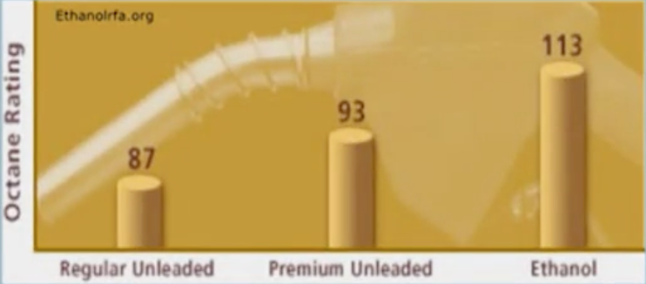Ethanol is used as a gasoline additive to raise its octane levels. The octane level of a gasoline is a measure of how efficiently it burns; the higher the octane level the lower amount of emissions like CO2 and soot of the gasoline when it is burned. In the past, toxic additives like methyl tert-butyl ether (MTBE) – which have been shown to pollute groundwater when gasoline containing MTBE was spilled at gas stations – have been used for the purpose of raising a gasoline’s octane level. Gasoline containing up to 15% ethanol can be used without altering the construction of the traditional combustion engine, but warranties offered by car manufacturers are void if fuel with >10% ethanol is used, so this essentially caps the percentage of ethanol within transportation fuel. A downside of ethanol as a transportation fuel is that it has a lower energy density than gasoline, which is why vehicles requiring more power (trucks, jets, etc.) do not use ethanol fuel.

In principle, adding a biofuel to gasoline reduces the CO2 emissions associated with transportation fuel consumption. In the case of corn ethanol however, much of the reduction is counteracted by the amount of CO2 emissions from the growing of corn to produce the ethanol.

*Why do we use corn to produce ethanol in the US?*

First of all, the US has the capacity to grow a lot of corn: > 300 million metric tons per year, by far the largest US crop in tonnage of grain/year.

As the farming lobby is an incredibly important one, the US government has always looked for ways to support farm incomes. In 2005, the federal government passed legislation which included incentives to use ethanol as a gasoline additive; this legislation achieved two objectives of increasing renewable energy usage within transportation fuels, and helped farmers increase demand for their crops.

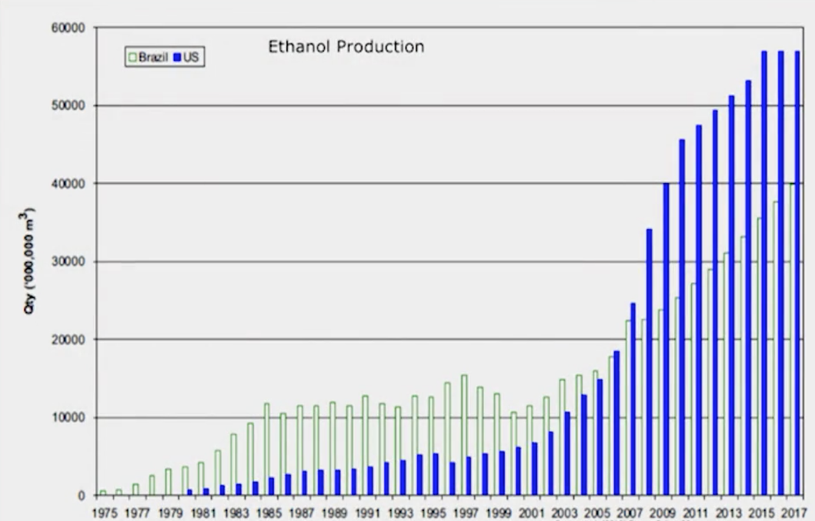Finally, the technology already exists to produce ethanol from corn seeds at a cost comparable to gasoline.

The incentives from the legislation in 2005 was effective in encouraging ethanol as a fuel, with the rapid expansion within the US since that time. As of 2013, all gasoline contains some ethanol, averaging between 5-10% depending on the state.

However, notice that ethanol production from corn is expected to level off in 2015-2017 (this graphic is from 2013). The federal renewable fuel standards were changed in 2012, and this legislation capped the total amount of ethanol that can be used as a gasoline additive and eliminated the tax incentives which encouraged such growth between 2005 and 2012.

The reason why the fuel standards were changed to de-emphasize corn ethanol was because corn is used as food for both humans and livestock.

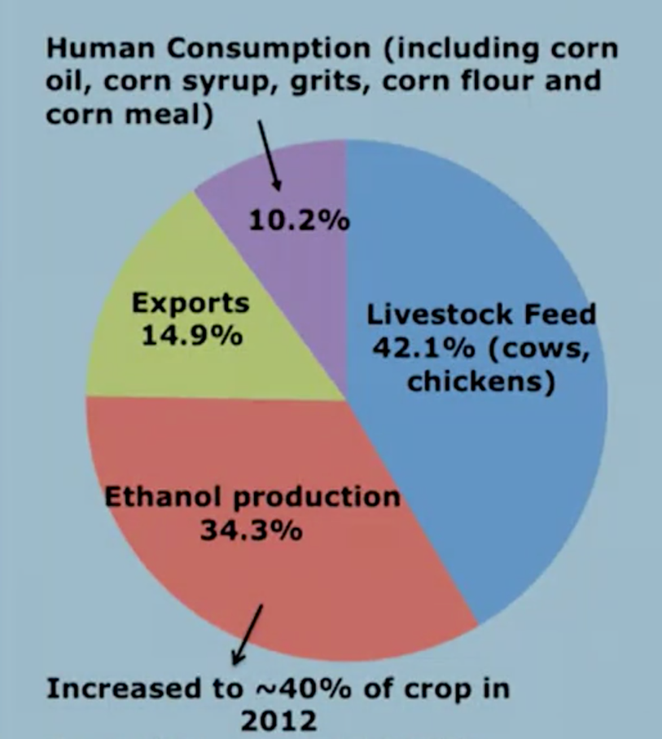With increasing levels of corn being used for ethanol, this helped drive up the price of corn (even though the largest determinant of the price of corn is the price of fuel). So while there are still requirements regarding the levels of ethanol within transportation fuel, the source of ethanol has changed to be from something not used as food.

*How is ethanol made from corn?*

Corn kernels are filled with starch, a sugar that is easily broken down to glucose, which is the starting material for ethanol production via fermentation. You can break down starch into glucose in one of two ways:

* Acid hydrolysis which breaks the chemical bonds of the starch
* Adding an enzyme called amylase which clips off the glucose compound from the starch

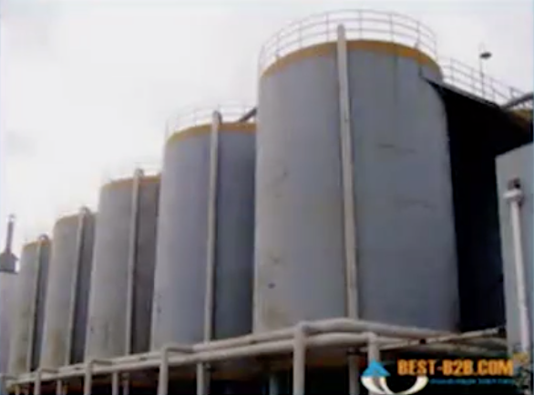Amylase is mixed up with corn mash in a giant cylinder and yeast is added in to metabolize the glucose in the absence of oxygen. This process of metabolism produces two waste products – CO2 and ethanol. Ethanol is not useful to the yeast – it actually is toxic to the yeast at certain levels – but rather is a byproduct of the metabolism. Because of the toxicity of ethanol to yeast, in practice the fermentation process can only yield ~10% ethanol.

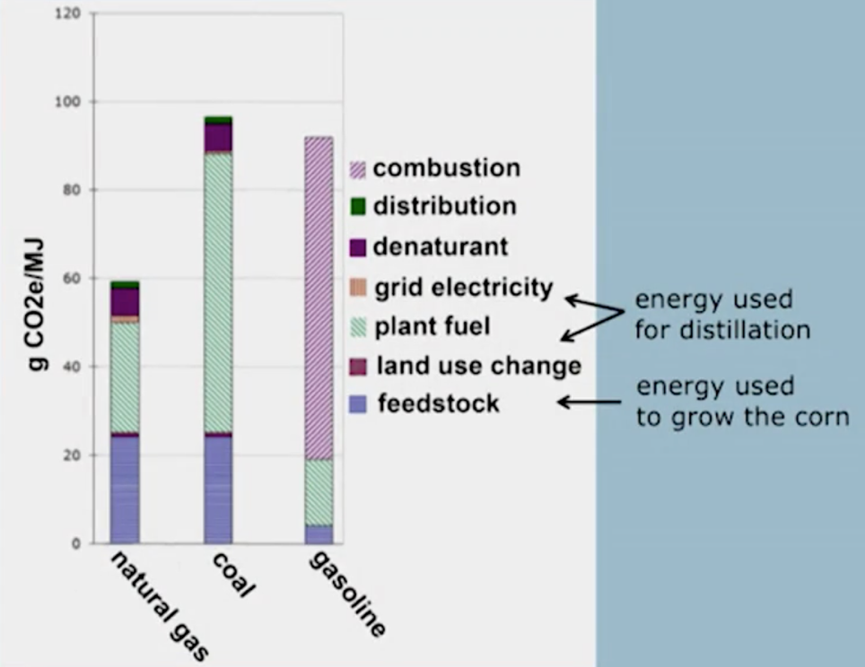Once the ethanol is produced within the fermenters, we can boil the resulting beer-like liquid. The boiling point of ethanol is lower than water, so the liquid is heated to a temperature above the boiling point of ethanol but below the boiling point of water. The ethanol vapor rises and is collected into a separate container which then cools the ethanol back into a liquid state, at roughly 99% purity.

This process of boiling large amounts of liquid takes an enormous amount of energy. Because of this, the overall reduction in CO2 emissions using ethanol instead of natural gas, coal or gasoline is not as dramatic as you would think – somewhere around 28% reduction in emissions using ethanol instead of gasoline. The emissions simply come from a different source – with traditional gasoline, most of the emissions come from combustion whereas ethanol production from corn emits carbon dioxide and limits the CO2 reduction achieved when the ethanol is combusted.

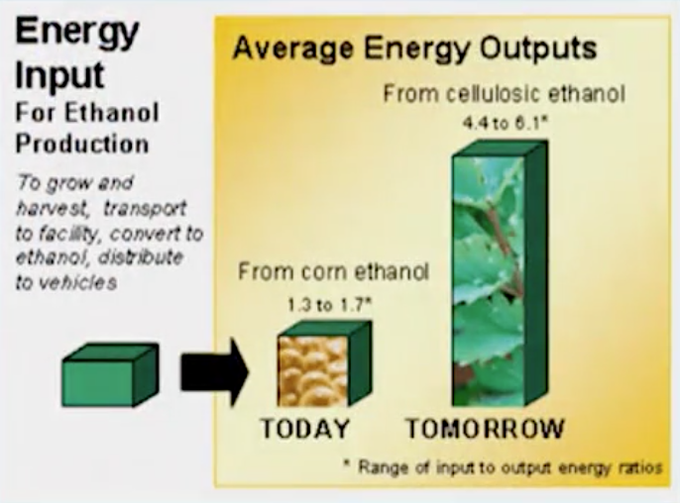Cellulosic ethanol has a much higher ratio of the amount of energy that is output to the amount of energy that is input to the production process, which may offer a longer-term solution to this problem that faces corn ethanol. However, ethanol produced via cellulose costs more so corn ethanol will be a viable option at least until the cost of cellulosic ethanol is below the cost of corn ethanol.